EXPERIMENT 1

AIM:
Study of Geiger-Muller Counter and counting statistics by γ-ray source.

SOURCE:
Na-22 is used as the gamma-ray source in this experiment.
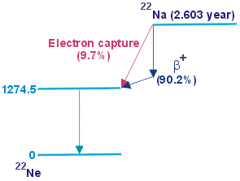
Figure 1: Decay scheme of Na-22

THEORY:
A Geiger-Muller counter has 2 parts – GM Tube and Electronic Counter

1) GM Tube:
The GM Tube has the following setup:
- A cylindrical chamber with the chamber walls as the cathode (-ve potential)
- A wire in the center of the chamber as the anode (+ve potential)
- An inert gas (like Argon) filled at low pressure
- Some halogen/alcohol/organic vapors mixed with the gas
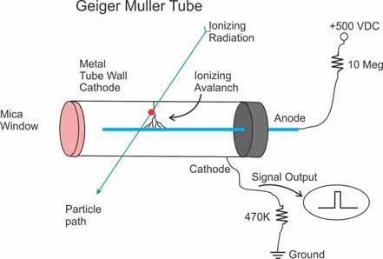
The voltage applied between the cathode and anode (typically hundreds of volts) produces a strong radial electric field inside the tube.
Figure 2: Structure of a GM Tube

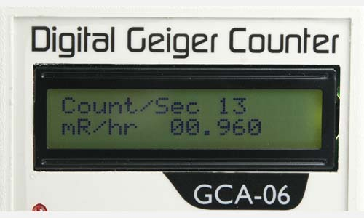
2) Electronic Counter:
Figure 3: Electronic Counter
It has the following setup:
- Pre-amplifier/Amplifier
- Discriminator
- Counter
- Display
- Audio Indicator

3) Working:
- When a particle enters the chamber, it strikes the gas and emits some electrons.
- Due to the strong electric field, the electrons are accelerated towards the anode wire and knock off more electrons from the gaseous atoms in their path. This is called an Avalanche or Townsend discharge. It creates approximately 10⁹ ion-electron pairs.
- As this avalanche reaches the wire, the counter measures this brief pulse of current (some nanoseconds wide)
- Since the pulse is a weak signal, the pre-amplifier/amplifier boosts it to keep it distinct from the surrounding noise.
- The Amplifier also shapes the signal into a standard digital-like pulse to ensure that all signals look the same, no matter how strong the Avalanche was. Else, a strong Avalanche would be counted as 2 pulses and a weak Avalanche would not be counted.
- The Discriminator filters out the surrounding noise by counting signals only above a specific voltage.
- The Counter is incremented each time a valid pulse is registered. It typically counts pulses per second (CPS) or pulses per minute (CPM).
- The Display shows the reading on an LCD screen or produces audible clicks each time a pulse is generated.
Inert gas is used inside the chamber as it does not react with the chamber walls and corrode them. It also does not recapture electrons to form negative ions; thus, the avalanche process is efficient.

4) Dead Time:
It is the short time after each pulse during which the counter cannot measure any radiation. This happens due to the following:
- After a pulse, there are a lot of positively charged ions left in the chamber.
- If they are left, they will strike other gaseous atoms and eject electrons, once again starting an Avalanche. Thus, a single particle would trigger multiple avalanches and be overcounted.
- To avoid this, some halogen/alcohol (quencher) is added in the chamber with the gas.
- The positively charged ions strike the quencher and excite the halogen atoms. This breaks the bonds of the molecule instead of releasing electrons.

Cl₂ Cl + Cl

- The single halogen atoms generated then combine with one another, releasing energy harmlessly (non-ionising radiation).
Cl + Cl Cl₂
- This way, the avalanche is stopped and the tube is ready for the next reading.
This entire process takes a certain amount of time, known as the dead time. It can vary from few $μs$ to few milliseconds.

5) Operating Regions of a Gas-Filled Detector:
The response of a gas-filled detector (current or pulse height) to applied voltage can be divided into several regions:
- Recombination Region: At low voltages, many ions recombine before being collected; the output is small and non-linear.
- Ionization Region: At slightly higher voltages, all primary ions are collected, but no secondary ionization occurs. The current is proportional to the number of primary ions and hence to the radiation intensity.
- Proportional Region: Secondary ionizations begin; the total collected charge is proportional to the energy of the incident particle.
- Geiger-Müller Region: A single ionizing event triggers a complete avalanche along the anode; all pulses have the same amplitude, independent of the particle’s energy. The counter works in this region.
- Continuous Discharge (Breakdown) Region: At very high voltages, continuous discharge occurs, damaging the tube.
The operating voltage is chosen in the plateau region of the GM characteristic curve - a range where the count rate remains nearly constant with increasing voltage. The threshold voltage marks the beginning of this plateau, and the breakdown voltage marks the end.

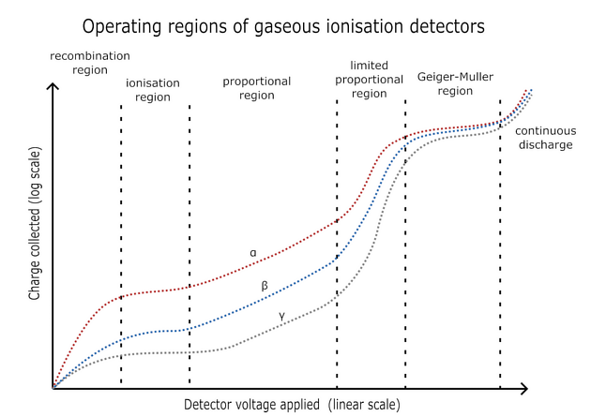
Figure 4: Operating Regions of GM Counter
6) Counting Statistics and Radioactive Decay:
Radioactive decay is a random process. The probability that a nucleus will decay in a small interval of time is constant and independent of its past history. Therefore, the number of decays (or counts) recorded in a fixed time interval follows a Poisson distribution.
For a Poisson distribution:
$$P(n)=\frac{e^{-\overset{ˉ}{n}}{\overset{ˉ}{n}}^{n}}{n!}$$
$P\left(n\right)$= probability of observing $n$counts,
$\overset{ˉ}{n}$= mean number of counts per interval.
The standard deviation in the number of counts is given by:
$$σ=\sqrt{\overset{ˉ}{n}}$$
By recording the number of counts in equal time intervals, one can verify that the experimental distribution of counts follows the Poisson law, confirming the random nature of radioactive decay.
For large number of counts, the Poisson’s Distribution approximates to the Gaussian Distribution:
$$f\left(x\right)=\frac{1}{σ\sqrt{2π}}ⅇ^{-\frac{{\left(x-μ\right)}^{2}}{2σ^{2}}}$$
$μ$ = mean of distribution
$σ$ = standard deviation

OBSERVATIONS:
The observations for this experiment can be found at this link:
https://docs.google.com/spreadsheets/d/1ufO1tbppc9bwsZXp6fTBmBU4C8yGdjmJN2aBJaaatuM/edit?usp=sharing
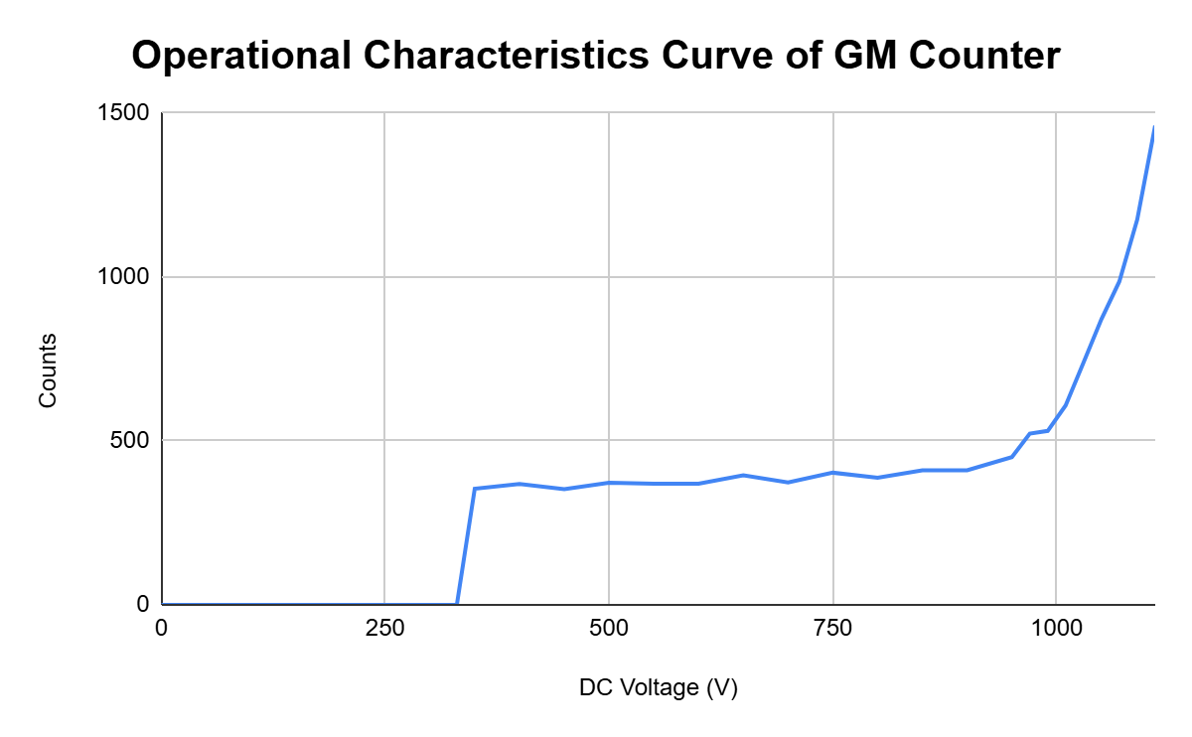
Figure 5: Operational Characteristics Curve
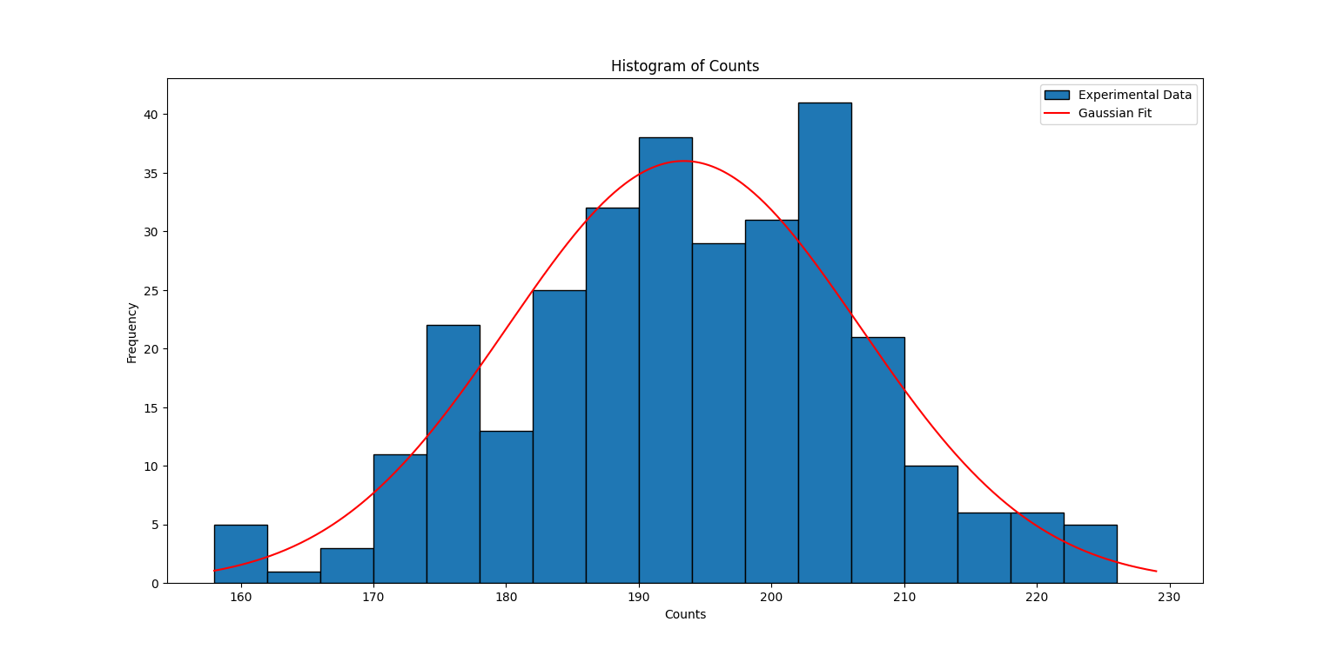
Figure 6: Histogram of Counts

ANALYSIS:
- As can be seen from Figure 5, the Geiger-Muller region for the operational characteristics curve is from 350 V -950 V. The operating voltage is chosen at the midpoint of the plateau. Thus, Operating Voltage = (350 + 950)/2 = 650 V.
- As can be seen from Figure 6, the Histogram for gamma-ray counts forms a normal distribution. This is expected, as for a large number of counts, the Poisson’s distribution approximates to a Gaussian (normal) distribution.

- $μ=193.39$ (Mean)
Experimental Standard Deviation:${ σ}_{e}=13.30$
Theoretical Standard Deviation: ${ σ}_{t}= \sqrt{μ}= \sqrt{193.39}=13.91$ (from Poisson’s Distribution).

- % deviation from theoretical $σ$ = $\frac{{ σ}_{t}-{ σ}_{e} }{{ σ}_{t}} ×100 \%=4.38 \%$
As can be seen, the experimental data follows the Poisson’s Law ( $σ=\sqrt{\overset{ˉ}{n}})$.
CONCLUSION:
- The operating voltage for the GM Counter comes out to be 650 V.
- The gamma-ray counts for Na-22 forms a Normal Distribution for large number of counts and it follows the Poisson’s Law.

